Practical No:07

**Aim:** Use Environment

a) Which account are you logged in? How do you find out?

**Using GUI**

**Go to settings, search Users and click on ‘Users’**

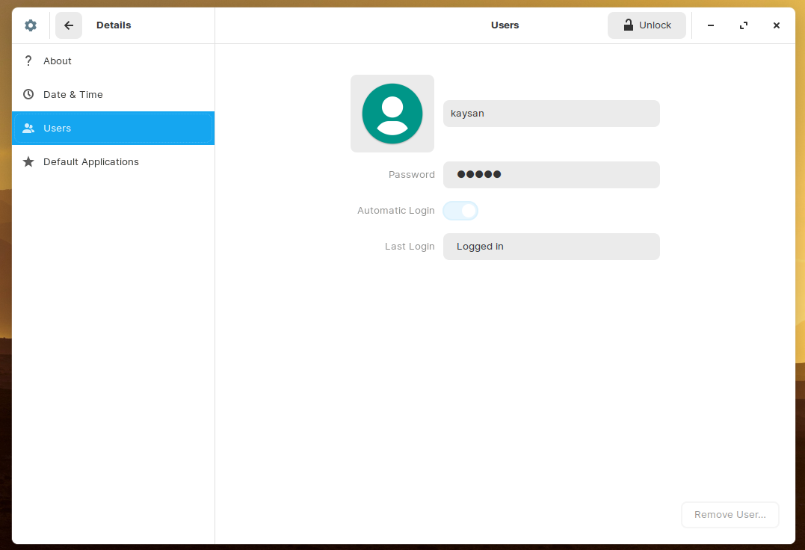

**Using Terminal**

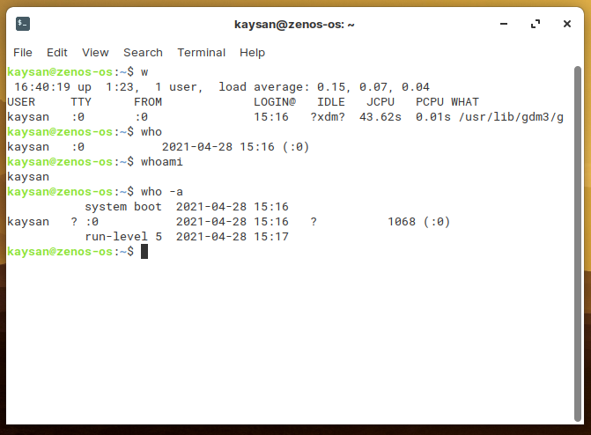

b. Display /etc/shadow file using cat and understand the importance of shadow file. How it’s different than passwd file.

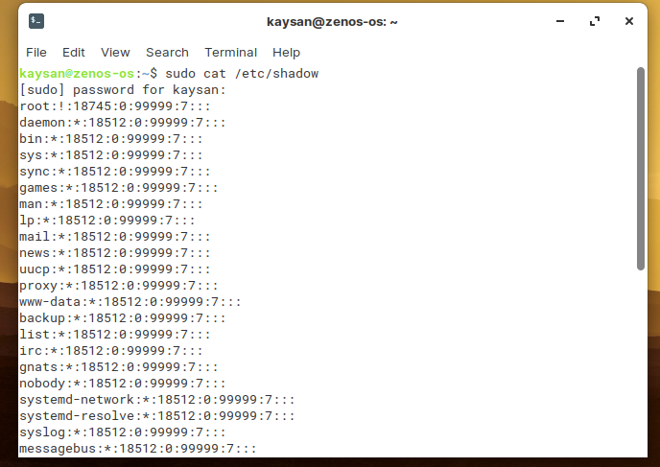

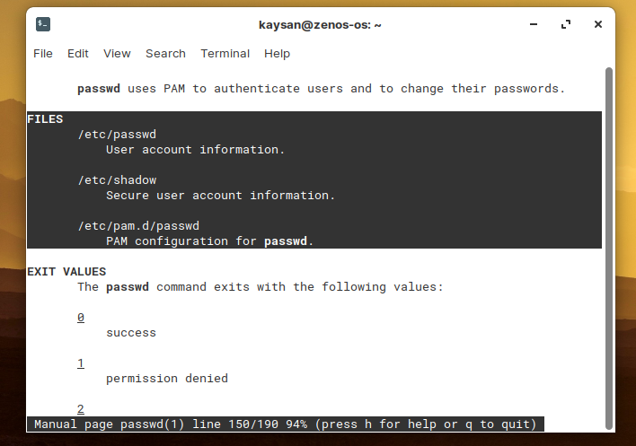

c. Get you current working directory

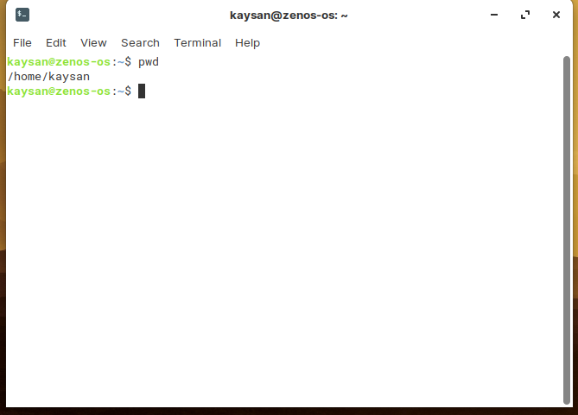

d. Explore different ways of getting command history, how to run previously executed command without typing it?

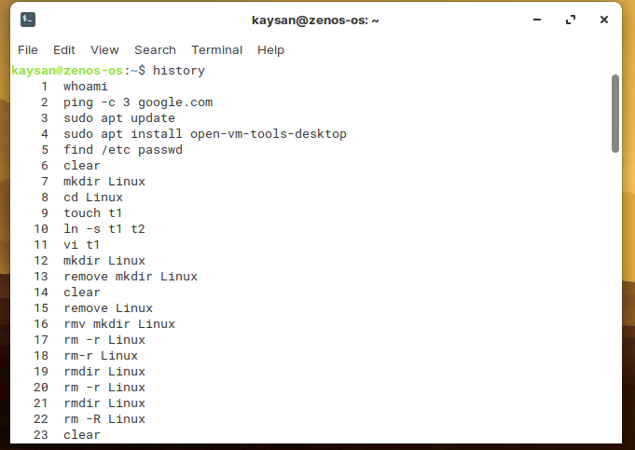

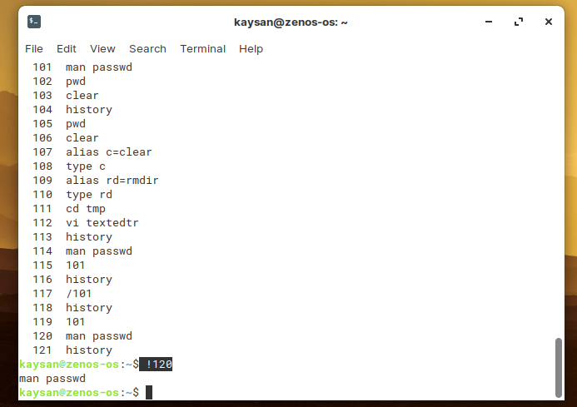

**To run a previously executed command without typing, we can press the upper arrow button to navigate and hit Enter button.**

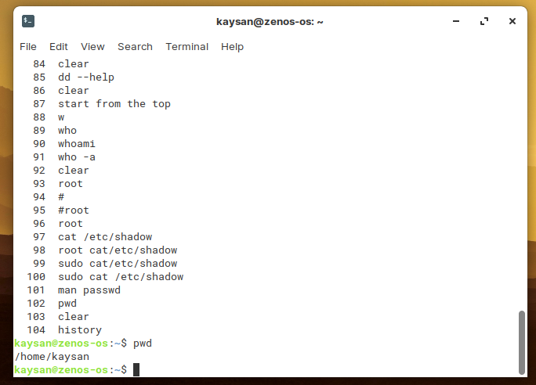

e) Create alias to most commonly used commands like.

